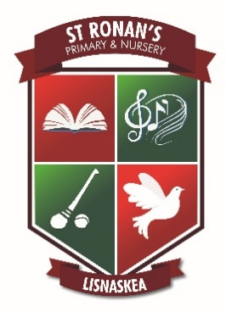
St. Ronan’s Primary and Nursery School
December 2023 Newsletter

Boof Fair – The book fair continues until Thursday 7th December. Parents are welcome to come in and purchase books from 2pm-3pm daily. If you wish to order books online, please use the link provided.

Christmas Celebrations – Our P.1 classes will be having their traditional Christmas Nativity Play on Thursday 14th December at 10.30am in the school hall. Their parents and families are welcome to attend.

Carol Service - A Christmas Carol service involving all children in the P4-P7 classes will be held on Monday 18th December at 7pm in Holy Cross Church. We look forward to welcoming our families and parish community to this special celebration.

Christmas Dinner – takes place on Wednesday 6th December. The cost is £2.60. Children may wear a Christmas jumper, Santa hat or tinsel and are asked to bring in £1 for charity.

St. Kevin’s College Musical – Our P6 and P7 classes have been invited to see the Matinee of their Musical ‘9 to 5’ on Wednesday 6th December at 10.30am.

Congratulations – We extend our warmest congratulations to Mrs Boyle on the recent birth of her new baby daughter.

PTFA Street Collection – A huge thank you to our PTFA and all the volunteers who organised and participated in the street collection on Saturday 2nd December. The proceeds will go towards providing much needed resources for our school.

Absence - We would gratefully request that parents inform the school of the reasons for their child’s absence in a timely manner. This can be done through the school’s website or alternatively send in an absence note.

Food Appeal - As part of our outreach into the community, we are asking for donations of food. Each child is asked to bring in one item of non-perishable food. We hope to create a hamper from each class in the primary school and one from the Nursery to present to St. Vincent de Paul and the local food bank. Your generosity will be very much appreciated at this time.

Christmas Cheer – Some of our classes will be making cards and letters for residents in Gortacharn Nursing Home and Drumhaw Fold. These will be delivered in the coming weeks.

Swimming - P7 will start swimming lessons in the Lakeland Forum on Thursday 11th January 2024. Cost is £1.50 per week.
Christmas Holidays - School will close at 11am on Thursday 21st December for the Christmas holidays. There will be no buses home or dinners that day. School re-opens on Thursday 4th January 2024.

Admissions 2024 - Admissions to Nursery and P1 for September 2024 open on Tuesday 9th January 2024 at noon. The process will close at noon on Friday 26th January 2024. Applications after that date and time will be considered as late applications. The process will take place online on the Education Authority website portal (www.eani.org.uk). If parents require clarification on making an application, they can contact the school Office for assistance. Details of our admissions criteria for Nursery and P1 will be available on the EA website from 17th December www.eani.org.uk/parents/admissions
There will be an opportunity for prospective parents to visit the school, meet staff and walk around the building on Friday 5th January. Details and images of life at St. Ronan’s can be seen on the school website www.stronansps.com

On behalf of the Staff and Board of Governors we wish all our children, parents and carers a very Happy Christmas and Best Wishes in 2024.
